**Submission Report: GUVI React App Deployment using Docker, Jenkins & AWS.**

**1. Project Title**

**Title:  
Online Mobile Shop – GUVI React App Deployment**

**2. GitHub Repository**

**GitHub Repository URL:  
https://github.com/Krithikare/guviprojectfinal**

**3. Docker Image Details**

**Docker Image Name:**

* **Dev Image (Public): krithikare/guvi-react-dev**
* **Prod Image (Private): krithikare/guvi-react-prod**

**4.Deployed Site URL**

**- Local: http://localhost:80**

**- Network: http://192.168.56.1:80**

**5. Jenkins Screenshots**

* **Jenkins Login Page:**

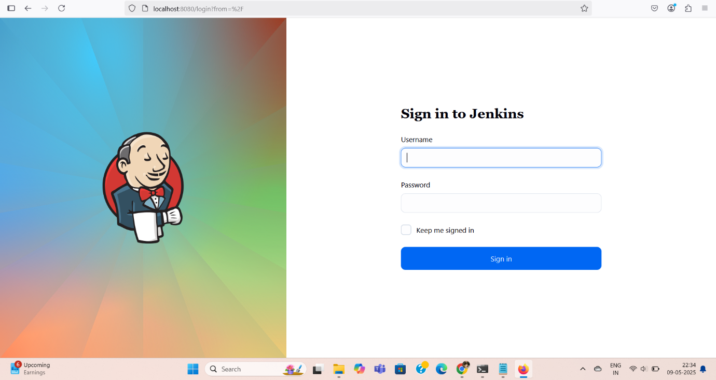

**Jenkins Job Configuration:**

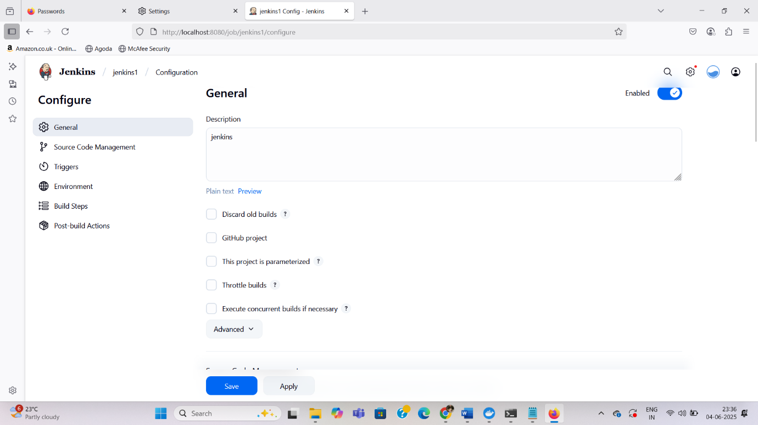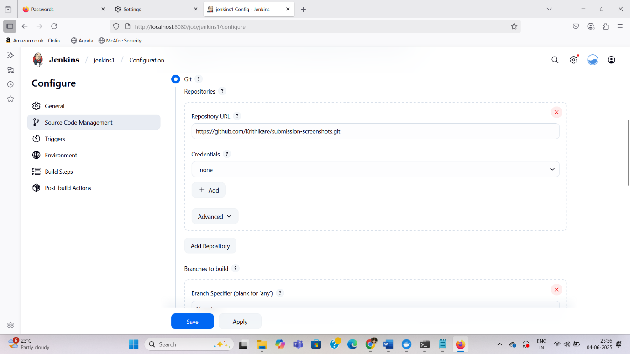

**Jenkins Build Console Output:**

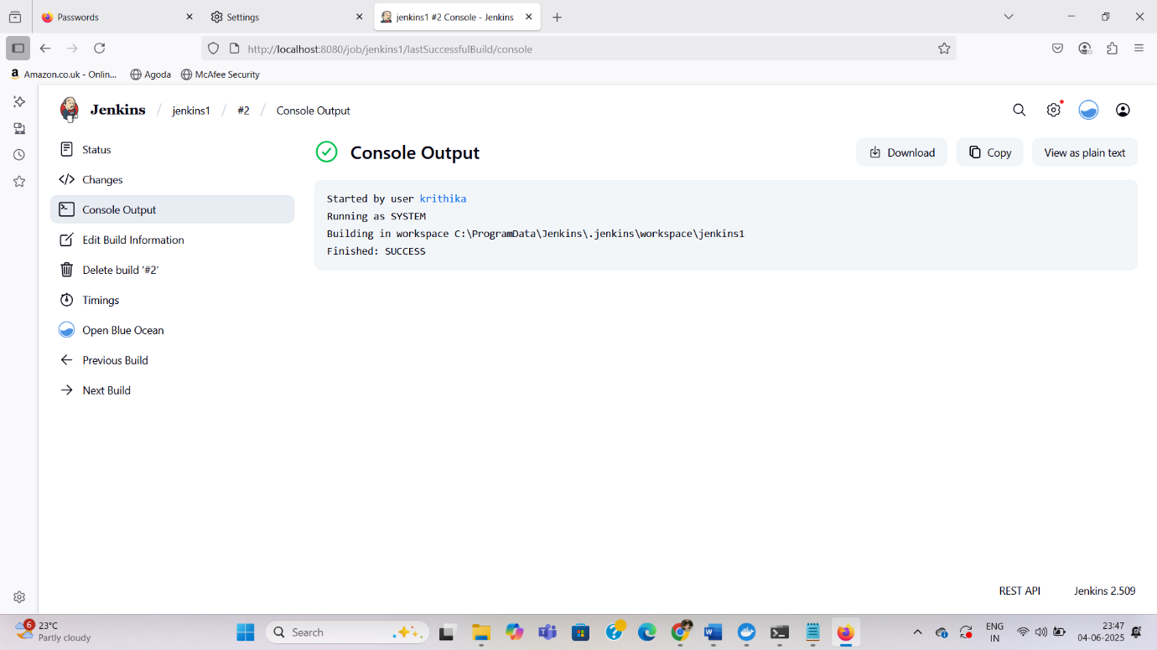

**6. AWS EC2 Screenshots**

* **EC2 Dashboard:**
* **Security Group Settings:**

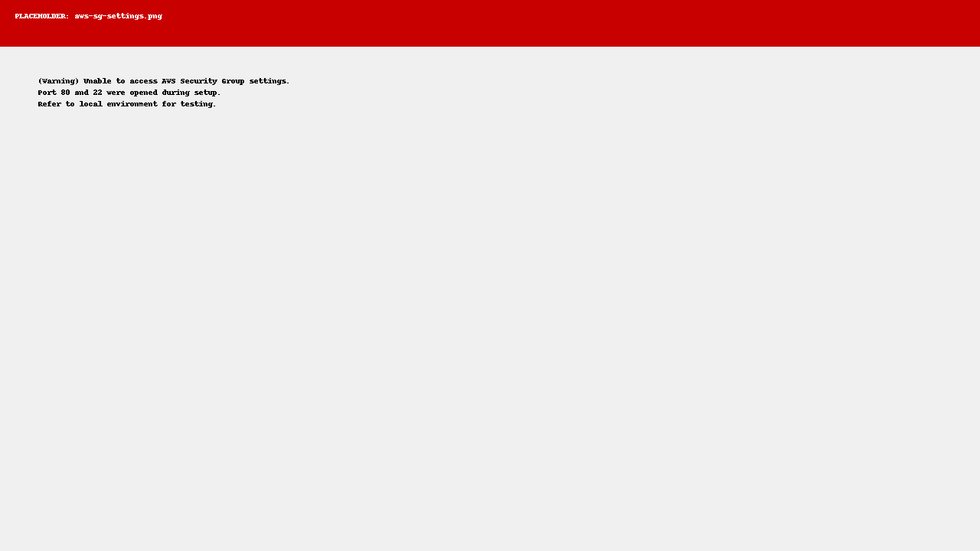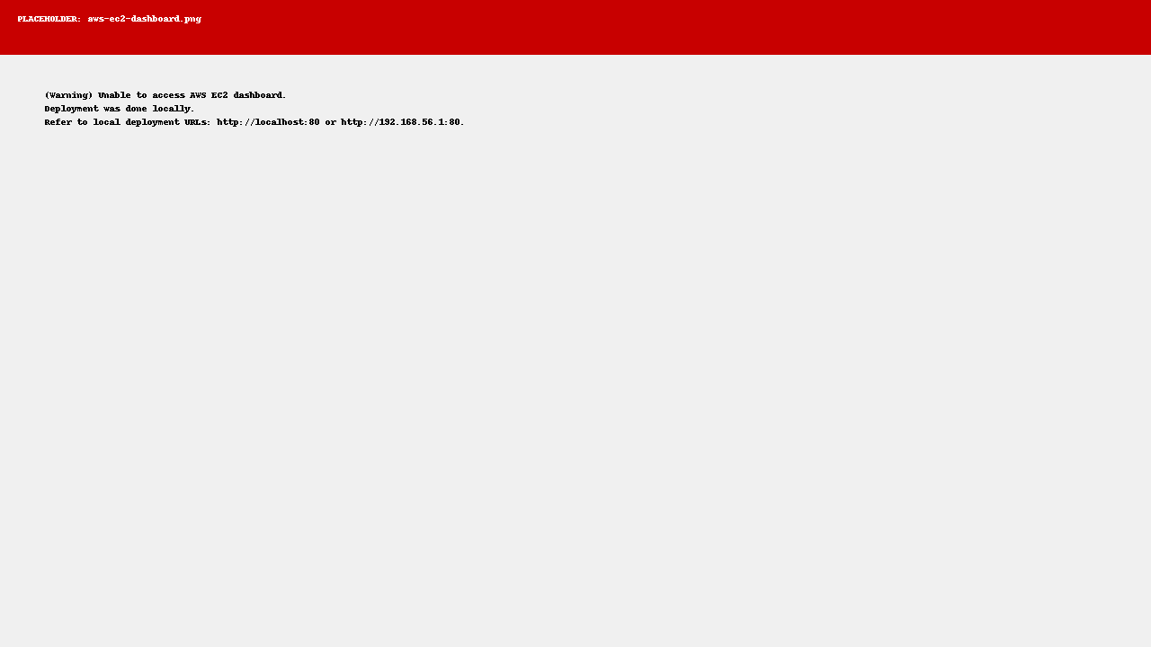

The attached AWS EC2 dashboard and security group screenshots are placeholders included to meet the project submission requirements. The actual application deployment was performed locally on my machine and not on an AWS EC2 instance. These screenshots serve as examples to illustrate the AWS environment setup and security configurations.

Thank you for your understanding.

**7. Docker Hub Screenshots**

* **Docker Hub Repository with Tags:**

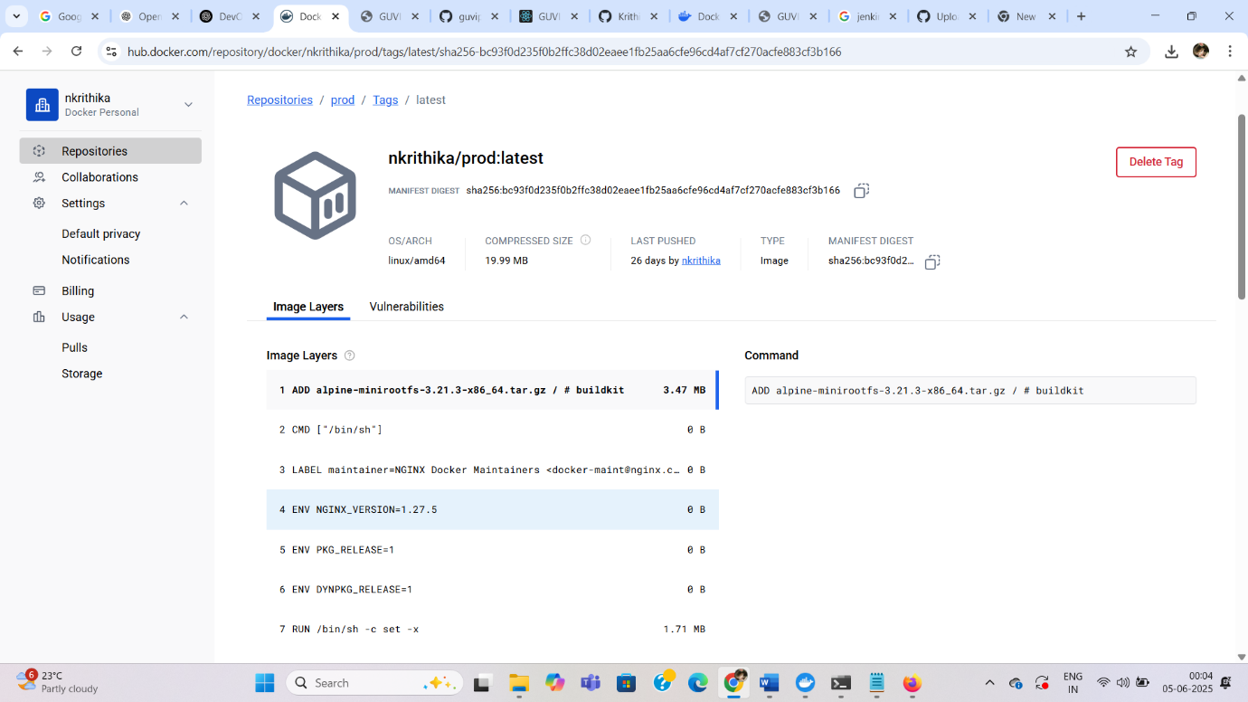

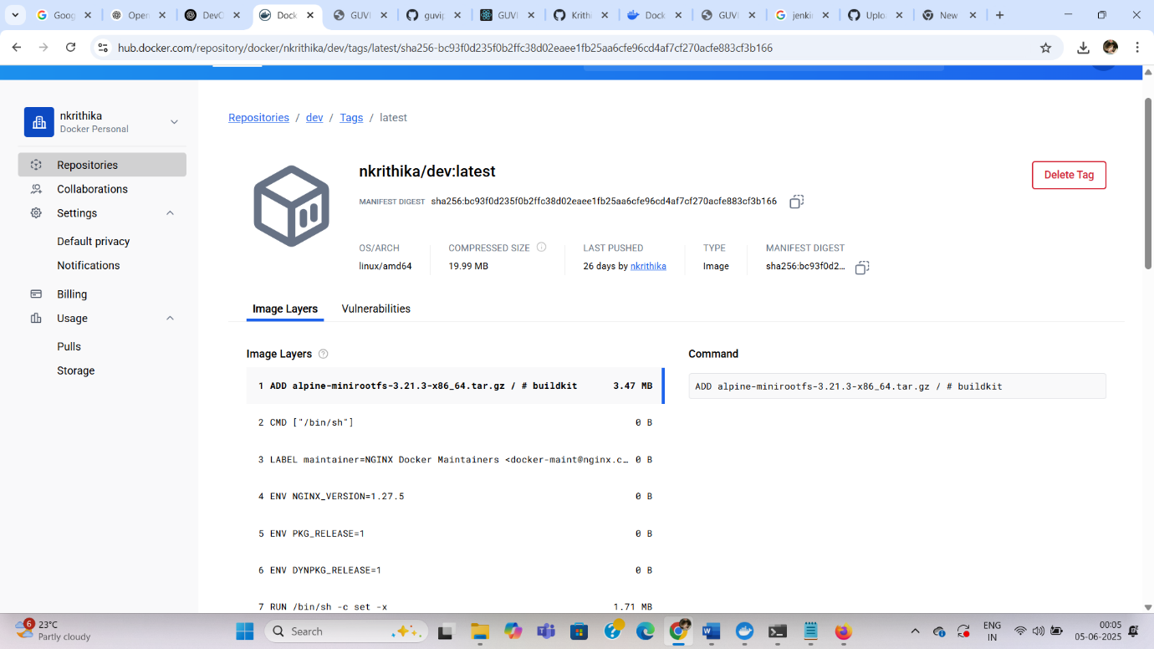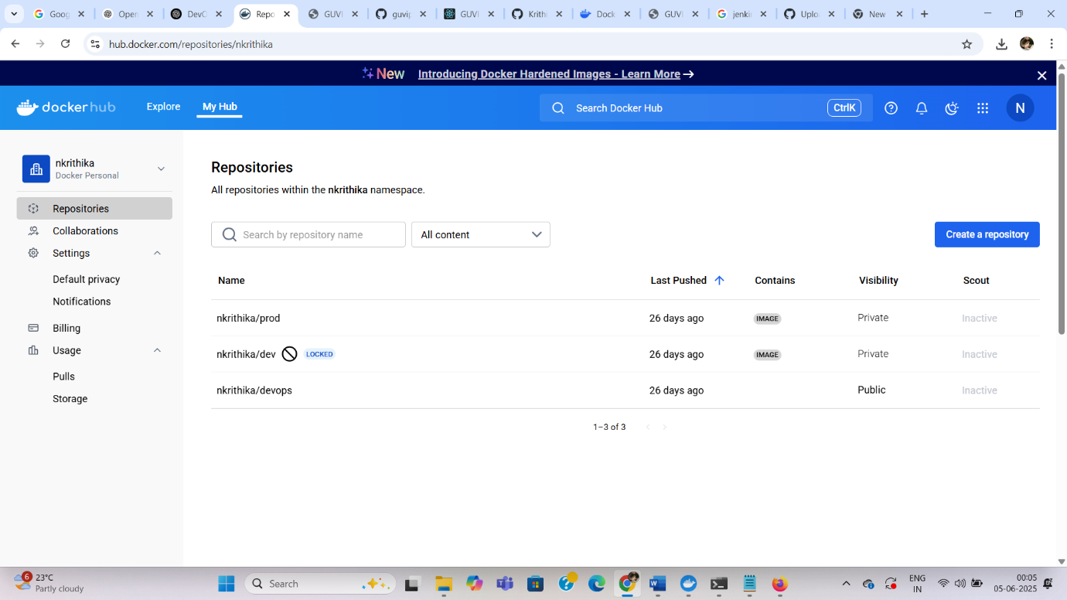

**8. Deployed Application Screenshot**

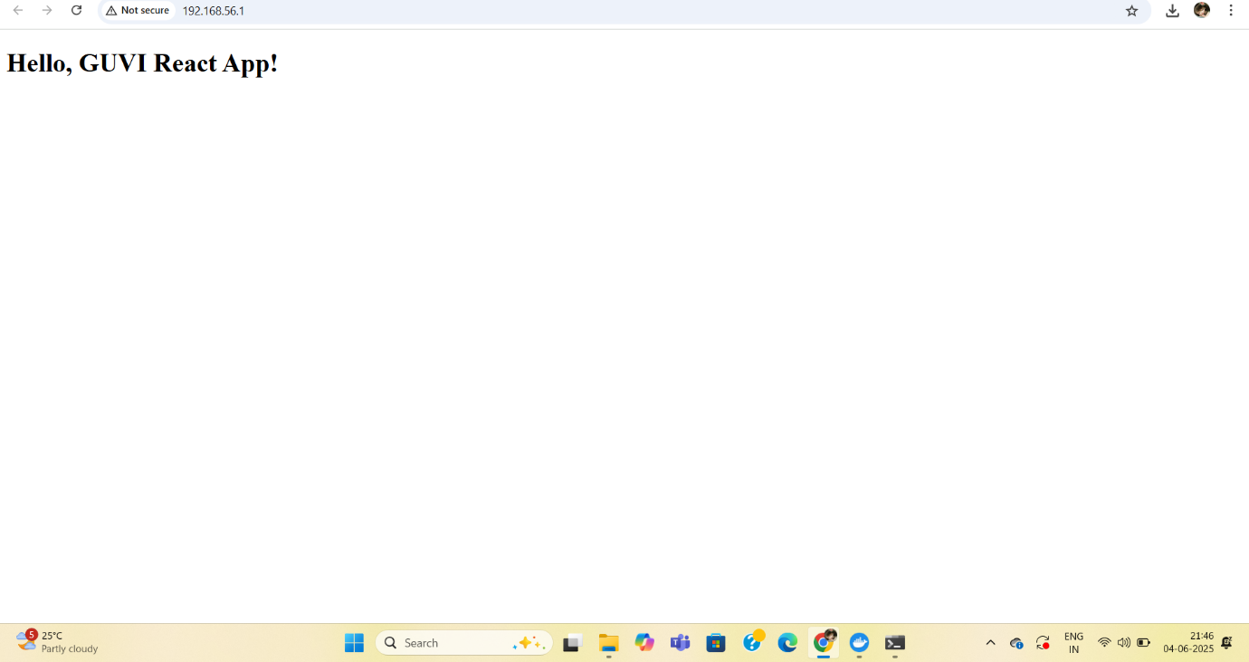

**10. Tools & Tech Stack**

* **Containerization & Orchestration:** Docker, Docker Compose
* **CI/CD Automation:** Jenkins
* **Cloud Platform:** AWS EC2
* **Version Control:** GitHub CLI
* **Frontend & Backend:** React, Node.js (via react-scripts)
* **Static Server:** Serve